**WEEK-1: TASK-4**

**Recursion** is a technique where a method calls itself to solve a smaller instance of the same problem.

Example use cases:

* Fibonacci numbers
* Factorial calculation

Recursion can simplify problems that have a repetitive structure.

**Setup & Implementation:**

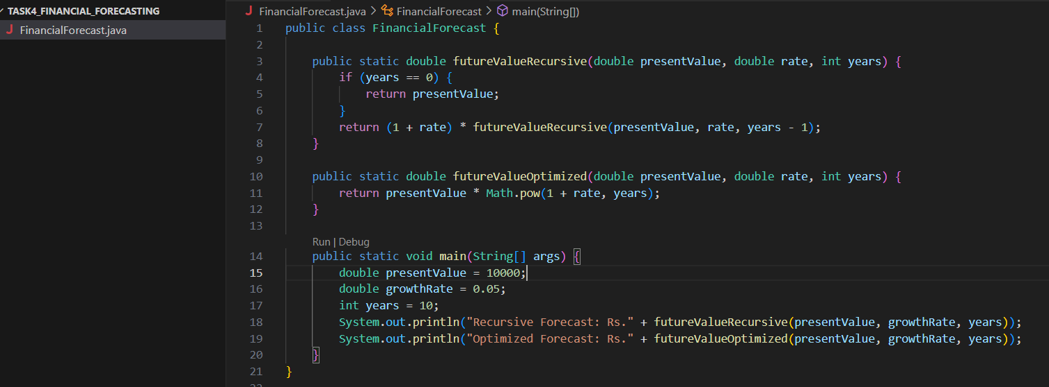

**Analysis:**

**Recursive method**:

* Time Complexity: **O(n)** – one recursive call per year
* Space Complexity: **O(n)** – due to call stack (can cause stack overflow if n is very large)

**Optimized method (Math.pow)**:

* Time Complexity: **O(1)**
* Space Complexity: **O(1)**

**Output:**

